Dominic D. LaRoche

STAT 574G

12/9/14- Lab 8

**Assignment 1:**

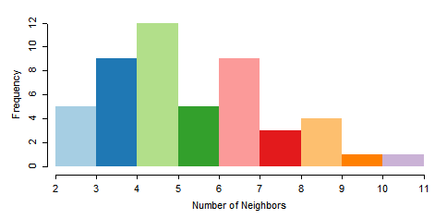

Based on the queen contiguity the number of neighbors is a little skewed to the right but there are no islands and it doesn’t appear that there is significant evidence of multi-modality.

**Assignment 2:**

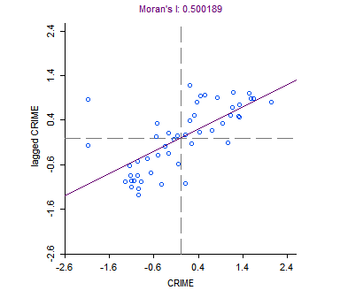

From the plot of Moran’s I we see that there is a positive relationship between the standardized crime value at a point (x-axis) and the neighboring (lagged) crime value. This plot indicates that there is indeed spatial autocorrelation.

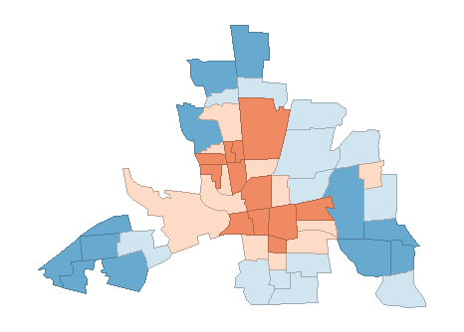

This choropleth map indicates that crime is localized in the center of the region with areas in the periphery having lower crime.

**Assignment 3:**

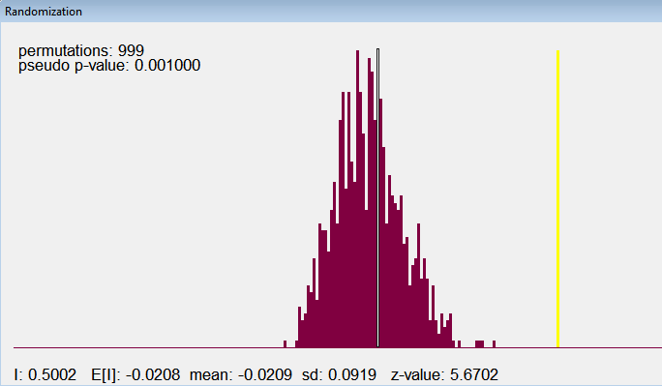

The permutation test for Moran’s I shows that is significantly different from the expected value under the null hypothesis of no spatial auto-correlation. Therefore, the spatial-autocorrelation is significant at alpha = 0.05.

**Assignment 4:**

Below are the results for the OLS regression model with the following form:

Crime = 68.61896 + (-0.2739315*HOVAL) + (-1.597311*INC) + ε,

which indicates that home value and income are negatively associated with crime. Based on Moran’s I the residuals do show spatial autocorrelation (p-value=0.0045107).

SUMMARY OF OUTPUT: ORDINARY LEAST SQUARES ESTIMATION

Data set : columbus

Dependent Variable : CRIME Number of Observations: 49

Mean dependent var : 35.1288 Number of Variables : 3

S.D. dependent var : 16.5605 Degrees of Freedom : 46

R-squared : 0.552404 F-statistic : 28.3856

Adjusted R-squared : 0.532943 Prob(F-statistic) :9.34074e-009

Sum squared residual: 6014.89 Log likelihood : -187.377

Sigma-square : 130.759 Akaike info criterion : 380.754

S.E. of regression : 11.435 Schwarz criterion : 386.43

Sigma-square ML : 122.753

S.E of regression ML: 11.0794

-----------------------------------------------------------------------

Variable Coefficient Std.Error t-Statistic Probability

-----------------------------------------------------------------------

CONSTANT 68.61896 4.735486 14.49037 0.0000000

HOVAL -0.2739315 0.1031987 -2.654409 0.0108745

INC -1.597311 0.3341308 -4.780496 0.0000183

-----------------------------------------------------------------------

REGRESSION DIAGNOSTICS

MULTICOLLINEARITY CONDITION NUMBER 6.541828

TEST ON NORMALITY OF ERRORS

TEST DF VALUE PROB

Jarque-Bera 2 1.835753 0.3993663

DIAGNOSTICS FOR HETEROSKEDASTICITY

RANDOM COEFFICIENTS

TEST DF VALUE PROB

Breusch-Pagan test 2 7.900442 0.0192505

Koenker-Bassett test 2 5.694088 0.0580156

SPECIFICATION ROBUST TEST

TEST DF VALUE PROB

White 5 19.94601 0.0012792

DIAGNOSTICS FOR SPATIAL DEPENDENCE

FOR WEIGHT MATRIX : columbus.gal

(row-standardized weights)

TEST MI/DF VALUE PROB

Moran's I (error) 0.222109 2.8400531 0.0045107

Lagrange Multiplier (lag) 1 8.8979986 0.0028548

Robust LM (lag) 1 3.7356906 0.0532617

Lagrange Multiplier (error) 1 5.2062139 0.0225063

Robust LM (error) 1 0.0439059 0.8340287

Lagrange Multiplier (SARMA) 2 8.9419045 0.0114364

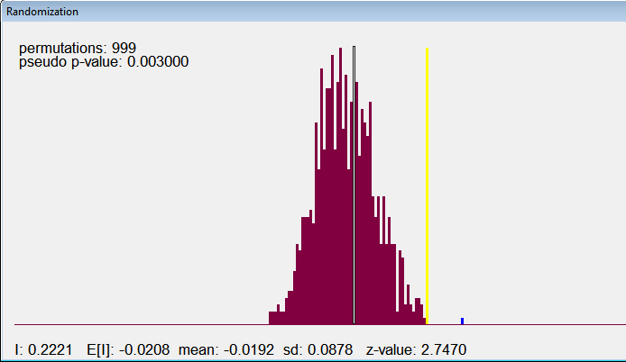

Based on the permutation test there does appear to be significant spatial auto-correlation.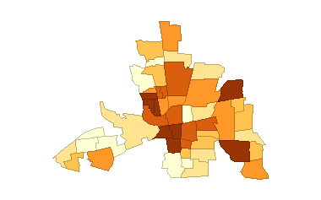

This choropleth map of the OLS residuals shows a similar pattern to the original crime map which suggests that the variables in the model did not completely account for the spatial pattern.

**Assignment 5:**

The results for the following regression model are given below:

Crime = (0.4233254 *W_Crime) + 45.60325 + (-0.2663348*HOVAL) + (-1.048728*INC) + ε.

Again, we see a negative association between crime and home value and income but we also see a strong positive association with the spatial effect. The likelihood ratio test suggests that the lag model fits better than the simple OLS model.

SUMMARY OF OUTPUT: SPATIAL LAG MODEL - MAXIMUM LIKELIHOOD ESTIMATION

Data set : columbus

Spatial Weight : columbus.gal

Dependent Variable : CRIME Number of Observations: 49

Mean dependent var : 35.1288 Number of Variables : 4

S.D. dependent var : 16.5605 Degrees of Freedom : 45

Lag coeff. (Rho) : 0.423325

R-squared : 0.646828 Log likelihood : -182.674

Sq. Correlation : - Akaike info criterion : 373.348

Sigma-square : 96.8572 Schwarz criterion : 380.915

S.E of regression : 9.8416

-----------------------------------------------------------------------

Variable Coefficient Std.Error z-value Probability

-----------------------------------------------------------------------

W_CRIME 0.4233254 0.1195104 3.542162 0.0003969

CONSTANT 45.60325 7.257404 6.283686 0.0000000

HOVAL -0.2663348 0.08909629 -2.989292 0.0027964

INC -1.048728 0.3074059 -3.411542 0.0006461

-----------------------------------------------------------------------

REGRESSION DIAGNOSTICS

DIAGNOSTICS FOR HETEROSKEDASTICITY

RANDOM COEFFICIENTS

TEST DF VALUE PROB

Breusch-Pagan test 2 24.50899 0.0000048

DIAGNOSTICS FOR SPATIAL DEPENDENCE

SPATIAL LAG DEPENDENCE FOR WEIGHT MATRIX : columbus.gal

TEST DF VALUE PROB

Likelihood Ratio Test 1 9.406534 0.0021621

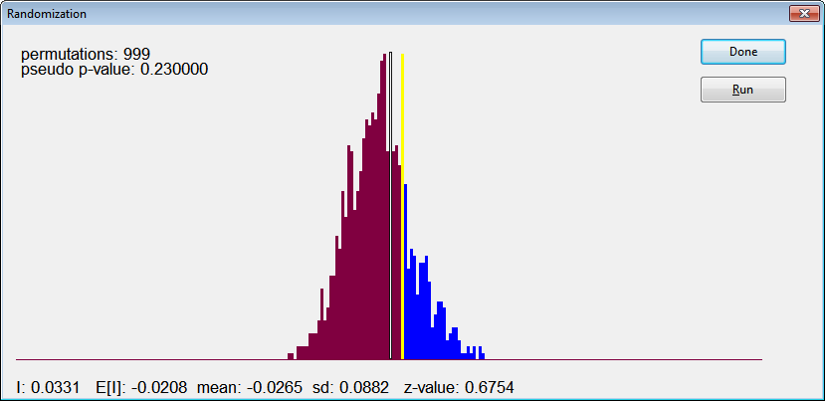

According to the permutation test we cannot reject the null hypothesis of no spatial auto-correlation in the residuals.

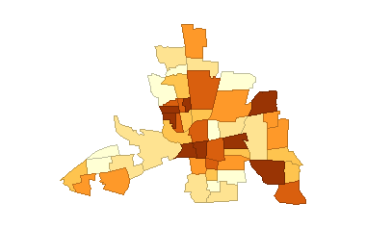

The choropleth map of the residuals from the spatial lag model do not show the same spatial pattern as the previous two maps (crime and OLS residuals), but rather the residuals appear more random.